**DAILY ONLINE ACTIVITIES SUMMARY**

|  |  |  |  |  |  |  |  |  |
| --- | --- | --- | --- | --- | --- | --- | --- | --- |
| **Date:** | **06/06/2020** | | | | | **Name:** | **Rahul J** | |
| **Sem & Sec** | **8th sem B sec** | | | | | **USN:** | **4AL16CS130** | |
| **Online Test Summary** | | | | | | | | |
| **Subject** | | **IOT** | | | | | | |
| **Max. Marks** | | **30** | | **Score** | | | **28** | |
| **Certification Course Summary** | | | | | | | | |
| **Course** | **Cloud foundations** | | | | | | | |
| **Certificate Provider** | | | **Great learning** | | **Duration** | | | **4.5 Hours** |
| **Coding Challenges** | | | | | | | | |
| **Problem Statement:**  **1.to read the number and**  **compute the series.**  **2. to count the number in th series.**  **3. to check whether number is palindrome or not.**  **4. to find the number between 0 and 50 which are**  **not divisible by 2 and 3.**  **5.micro and array update** | | | | | | | | |
| **Status: Solved** | | | | | | | | |
| **Uploaded the report in Github** | | | | | **Uploaded** | | | |
| **If yes Repository name** | | | | | **Rahul_j** | | | |
| **Uploaded the report in slack** | | | | | **Yes** | | | |

Online Test Details:

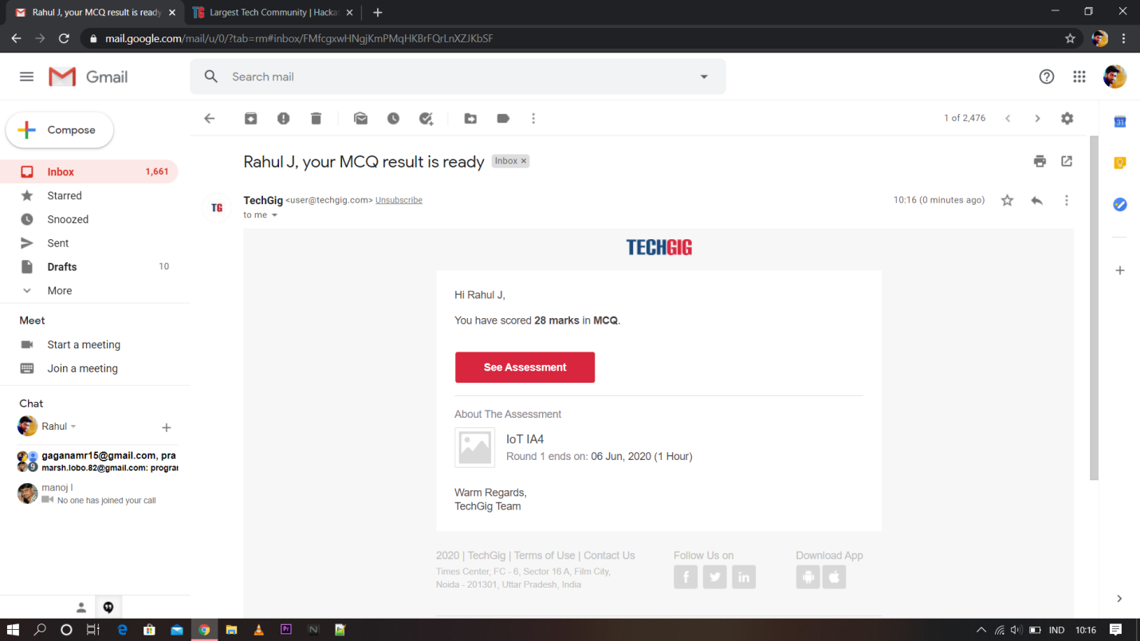

Certification Course Details:



Coding Challenges Details:

|  |
| --- |
|  |
|  |  |
|  |  |
|  |  |
|  |  |
|  |  |
|  |  |
|  |  |
|  |  |
|  |  |
|  |  |

#include <stdio.h>

#include <string.h>

void swap (char *x, char *y)

{

char temp;

temp = *x;

*x = *y;

*y = temp;

}

void permute(char *a, int i, int n)

{

int j;

if (i == n)

printf("%s\n", a);

else {

for (j = i; j <= n; j++)

{

swap((a + i), (a + j));

permute(a, i + 1, n);

swap((a + i), (a + j));

}

}

}

int main()

{

char a[20];

int n;

printf("Enter a string: ");

scanf("%s", a);

n = strlen(a);

printf("Permutaions:\n");

permute(a, 0, n - 1);

getchar() ;

return 0;

}